- Access the guide documentation:  
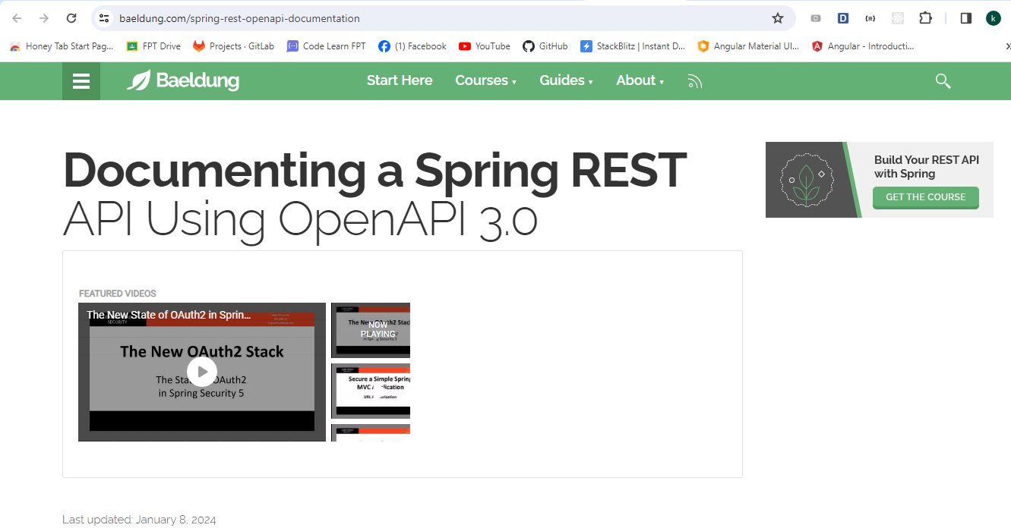

Link: <https://www.baeldung.com/spring-rest-openapi-documentation>  
- To checking:  
+ Access: <http://localhost:8082/api-docs>  
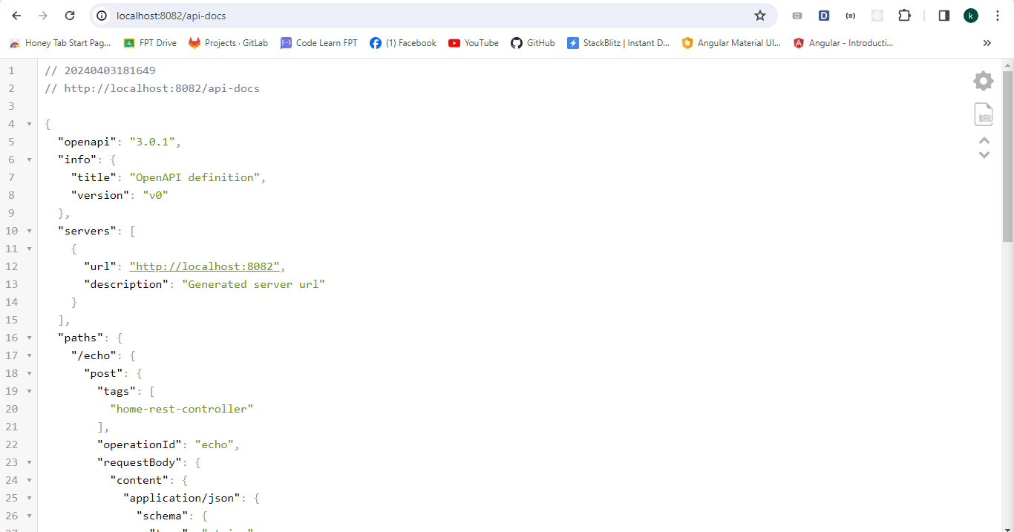

+ Access: <http://localhost:8082/swagger-ui/index.html>